Tyler Wiggins

CST-247

Bill Huges

3/2/2021

Activity 4

Link to the GitHub for Activity 4: https://github.com/FLAME270/CST-247_Activity-4.git

Figure : Running a .html file from localhost/ajaxdemo

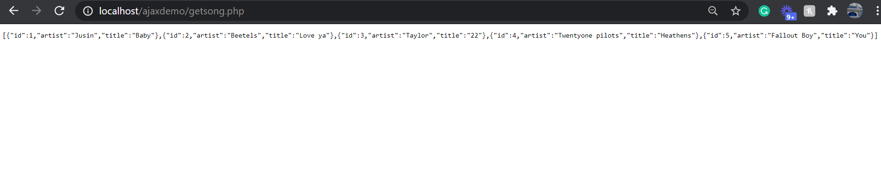

Figure : json getsong.php file being ran in localhost

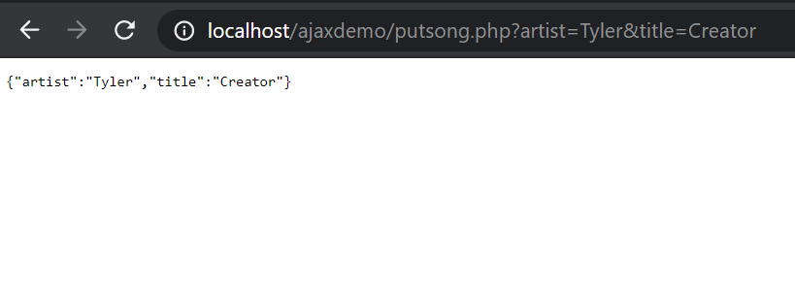

Figure : putsong.php with new artist and song title

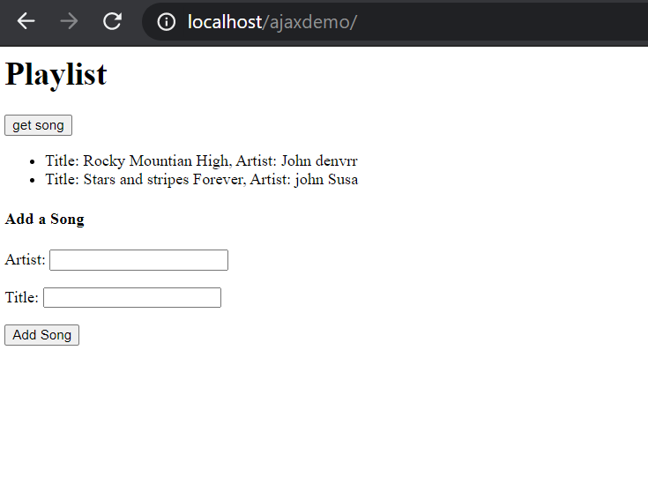

Figure : page to add and get songs

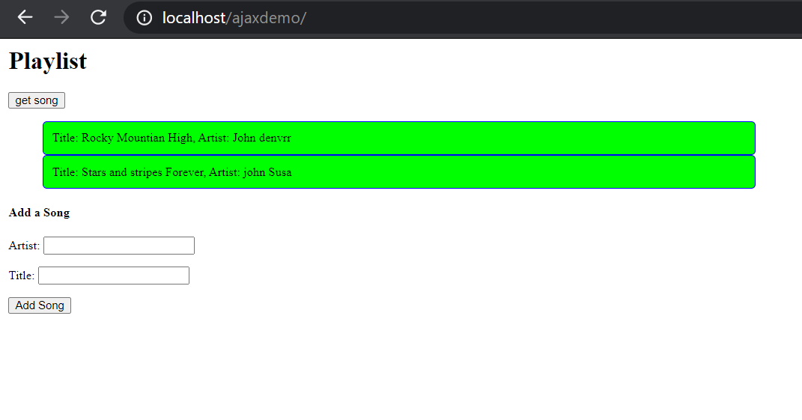

Figure : added css to our page

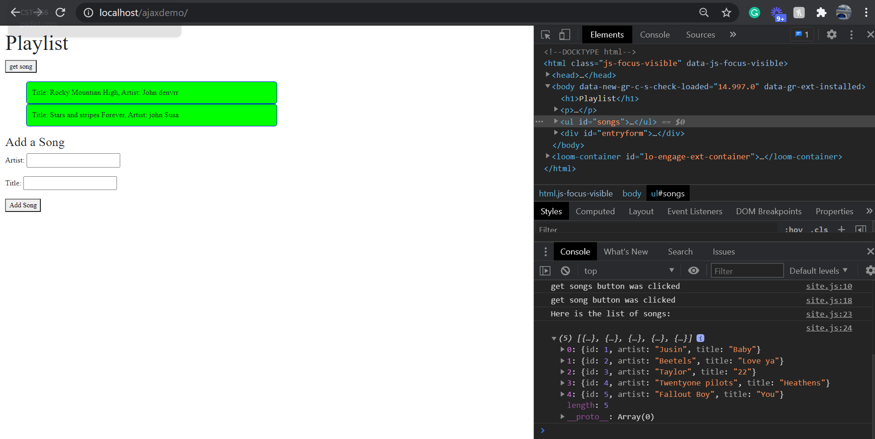

Figure : uses ajax to return the list of songs from the getsong.php file in json format

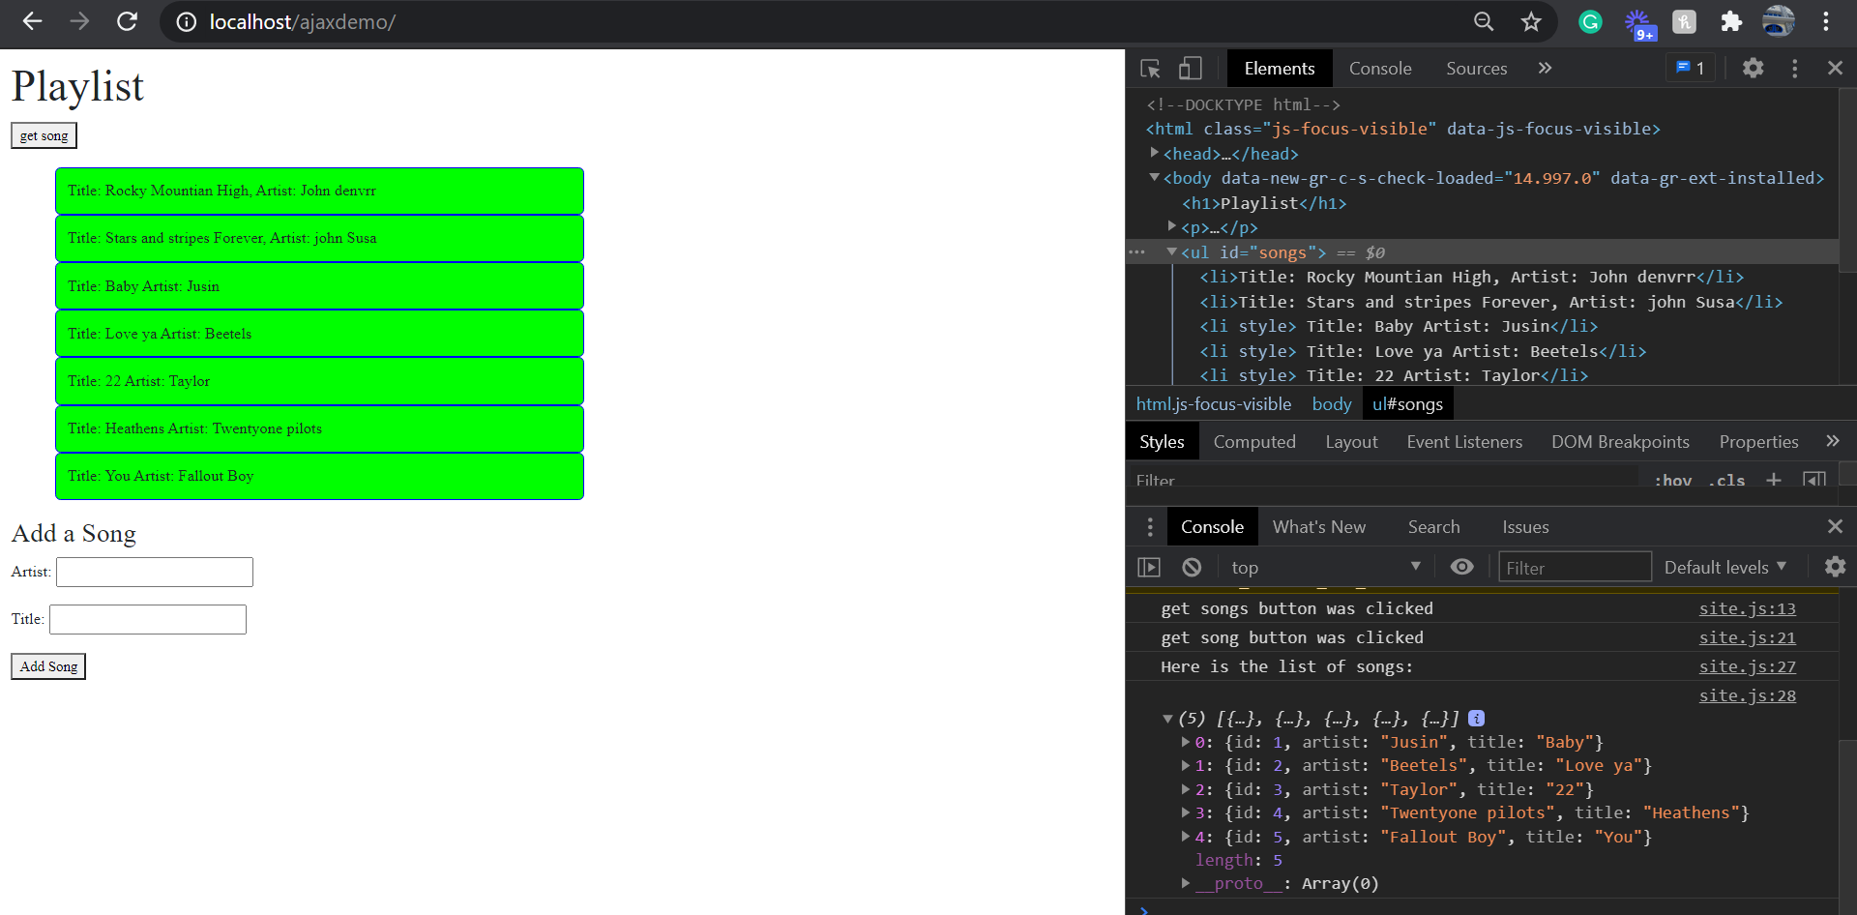



Figure : made a $.each loop that gets the song and artist and prints out the list on the ajaxdemo website and in the console

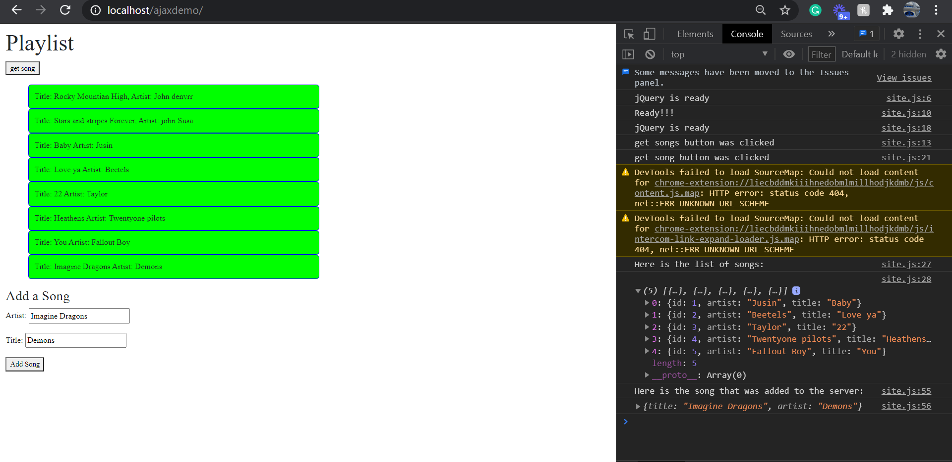

Figure :Added more functionality, where you can add new songs to the playlist

PART 2:

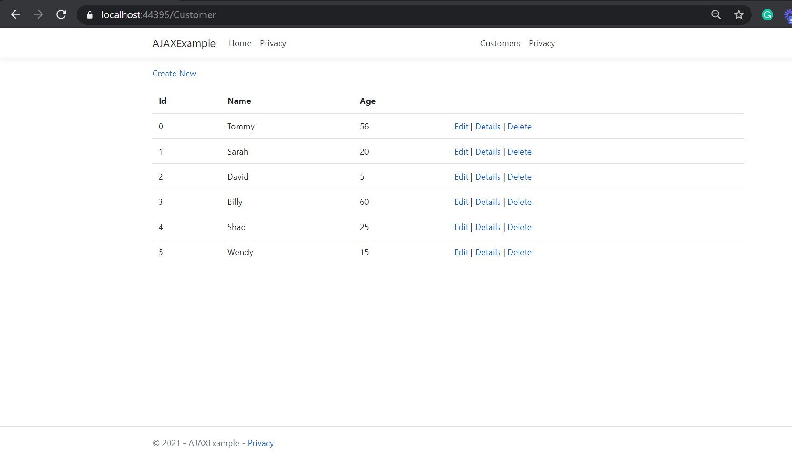

Figure : Made a customer array list, and returned it in the view

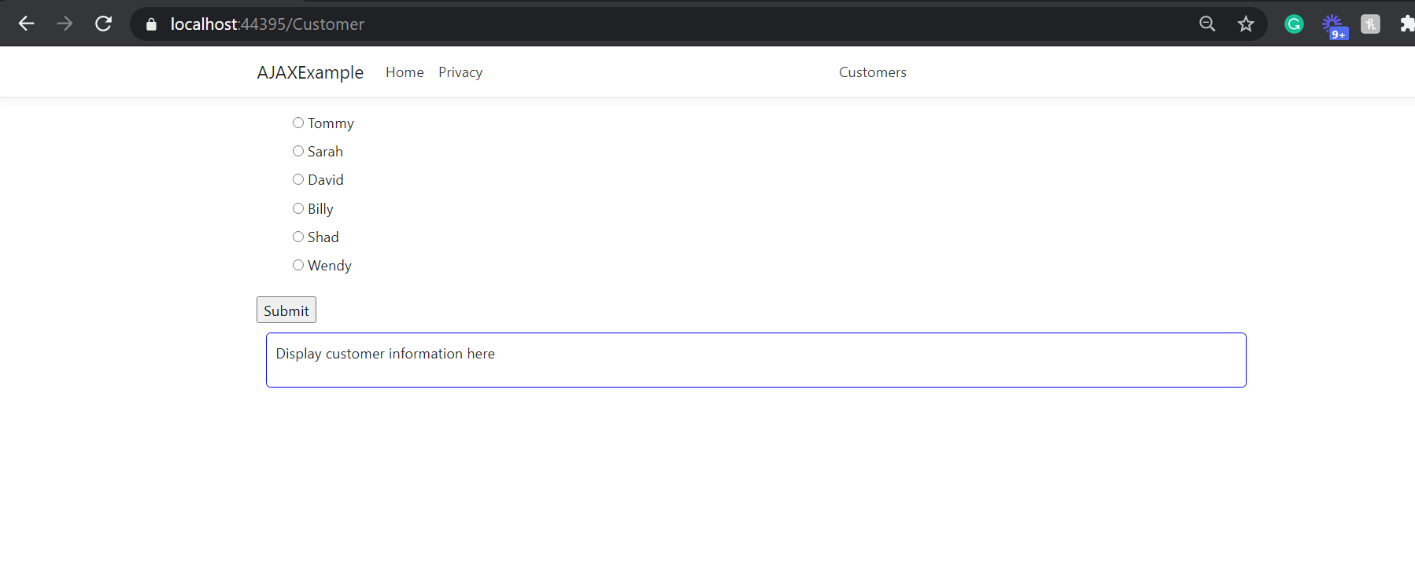

Figure : Turned the list of customers to show a radio button and submit button

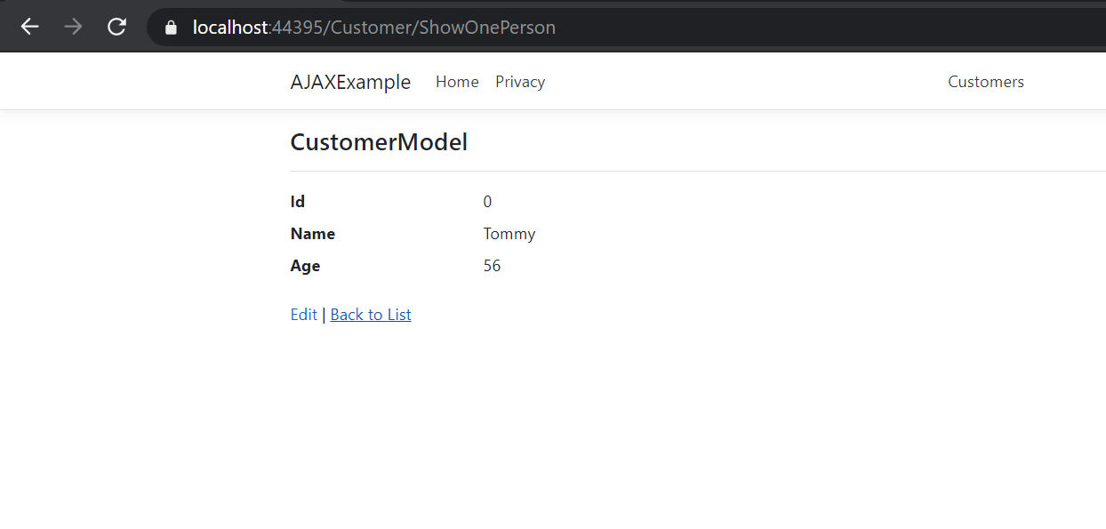

Figure : Returns the user info when the submit button is clicked

Figure 12: Added a partial view with javascript

PART 3:

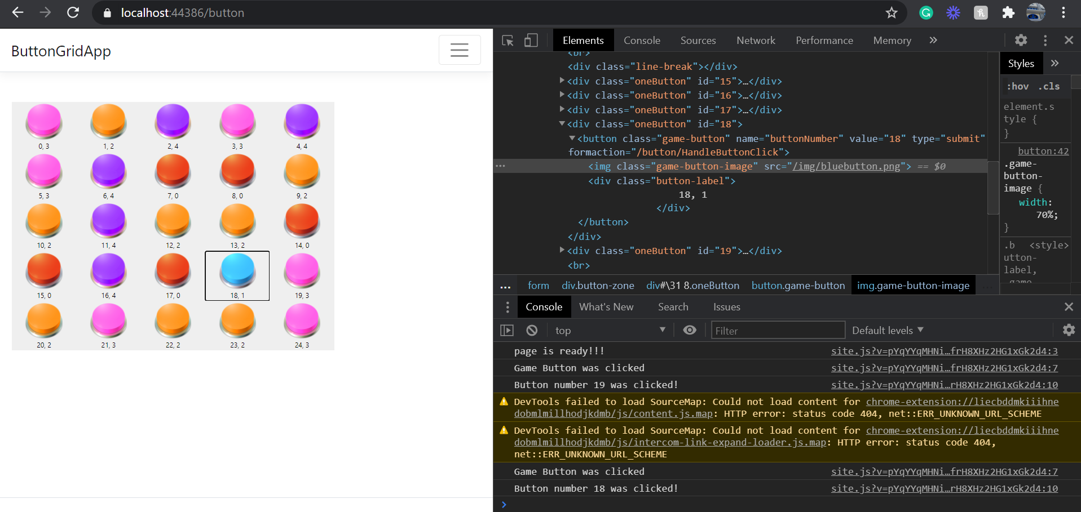

Figure : added console logging in the site.js file and now it logs the button id

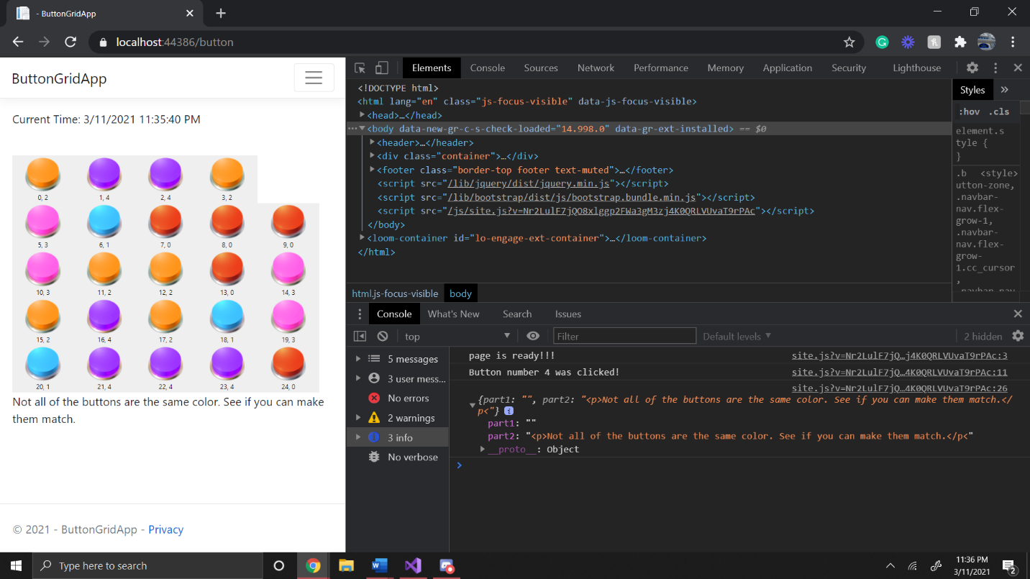

Figure : added the win condition to display in the console using javascript and ajax

PART 3:

Figure : screenshot of working product application

Figure : Added console logging and ajax to log when buttons are clicked or data is stored